Types of containers for power
You can provide pigs with different feeders depending on the location of the pig population, the size of the pigsty and financial possibilities:
- Group capacity, designed for a large number of animals.
- Mobile pig feeders.
- Individual do-it-yourself pork feeder designed to feed one individual.
- Stationary and mobile.

Drinking tanks
Breeding pigs in the subsidiary, as well as in the farms, involves the improvement of not only the feeders, but also the drinkers for the pigs.
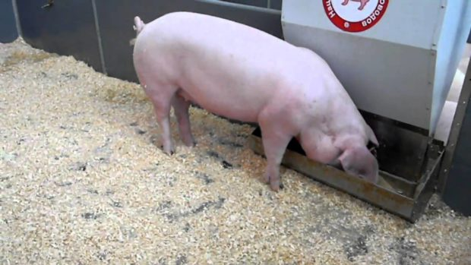
Such designs can be purchased at any specialized store or do it yourself.
Drinkers for pigs must meet sanitary standards and requirements:
- Pure condition.
- Water availability.
- Having a fresh drink.
- Uninterrupted supply of clean water.
- Long service life and durability.
- Convenience of cleaning and washing.
Drinkers for pigs can be made of different materials and have different equipment.
The best option is metal products made of anti-corrosion metals, equipped with a filter to maintain cleanliness and a device that regulates the water supply.
In winter, in open spaces, the probability of water freezing in tanks is high. Therefore, the installation of a water-heating device would be expedient under the bottom of the tanks.
Depending on the method of water supply, drinking bowls for pigs are of several types.
Cup systems. The advantage of this design is the economical consumption of drinking and ease of drinking. The disadvantage is rapid clogging and the need for frequent washing.
Drinkers for pigs, equipped with nipples, are versatile. These are drinkers for piglets and adults. This is a simple design, which consists of three elements - a nipple-shaped valve, a metal housing and a special seal. By pressing on the valve, the hoofs activates the water supply mechanism from the tank or water supply system. The main advantage of such systems is hygienic, economical and rational use of water, reliability.
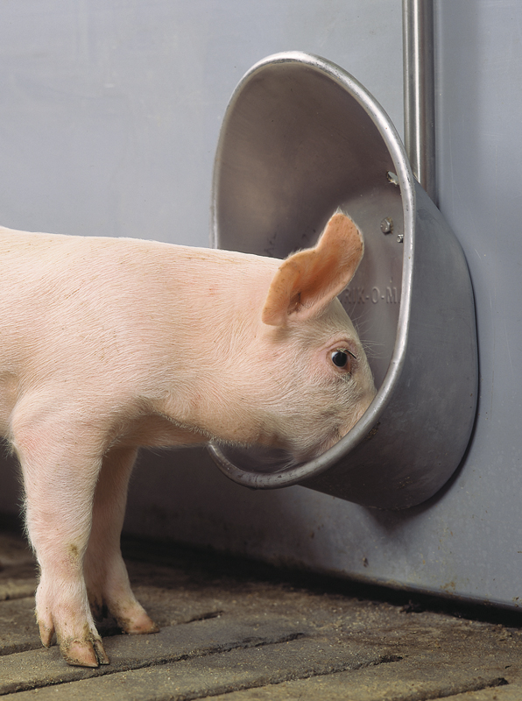
For the convenience of watering young pedigree, it is necessary to use small-sized tanks with a weakened valve; drinkers for mature pigs are equipped with large nipples.

Independent production
The easiest thing to do is to make a finished trough or a metal box 50 cm in height — so the pigs won't get into it with their feet, and so that they do not turn over the container, fasten it to a wall or other stationary object so that it can be disconnected — to wash the container.
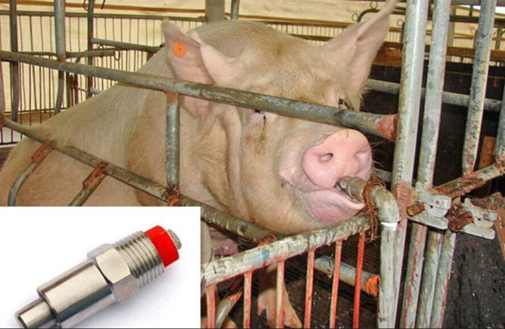
A good idea is to hang a small metal or plastic trough on a wall at an angle. The water will be clean, but it will have to be updated daily.
An excellent and inexpensive option is to take half of the plastic pipe, make a cap on the sides, and for stability - build a rectangular gutter from old brick. This drinker is easily removed for washing, and animals can not get into it.

